Phase 2 | Business & Product Alignment
- Align business inputs with products before Phase 2 startup
- Focus on: User Case/Info Flow/Fund Flow

1. Phase 2 Background and Objectives

1.1.1 Core business objectives
- Phase 2 hopes to solve the main business problems:
- Signs of success after achieving Phase 2:

1.1.2 Business boundary assumption
- Phase 2 leans more towards (multiple options available):
Build underlying capabilities, market expansion, business model expansion
- Clearly define directions (if any) that are not within the scope of Phase 2.

1.1.3 Business boundary assumption
- Phase 2 leans more towards (multiple options available):
Build underlying capabilities, market expansion, business model expansion
- Clearly define directions (if any) that are not within the scope of Phase 2.

1.1.4 Business Model address
AIX Phase 2 Business Model

2. R&R & Contractual Relationship

2.1 Roles & Responsibilities
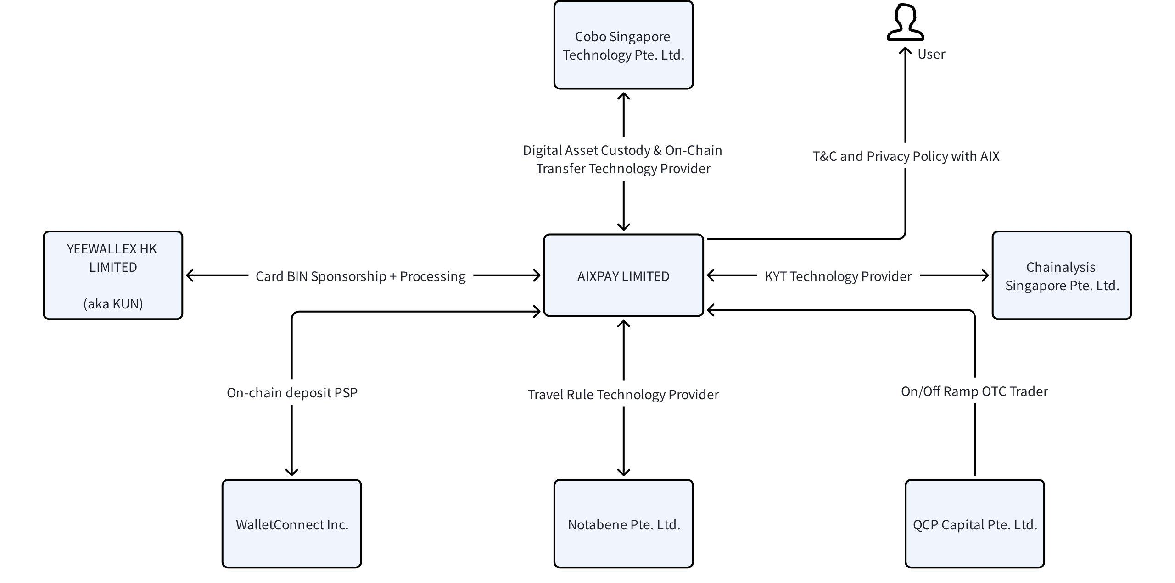

3. MVP Function

3.1 User Case
Domain | Functional Flow | Information source/interaction pattern | Note
Account opening KYC | Passport OCR | AIX → KUN → AAI → KUN | Passport information recognition
 | liveness+Face Comparison | AIX → KUN → AAI → KUN | Live detection and face comparing
 | POA | AIX → KUN → AAI → KUN | Upload proof of address
 | KYC Agreement | AIX | User confirms KYC related agreement
Card management | View card information | AIX → KUN
 | Card activation | AIX → KUN
 | Set PIN | AIX → KUN
 | Change PIN | AIX → KUN
 | Lock Card | AIX → KUN
 | Unlock Card | AIX → KUN
Token On-Chain Transfer | Token on-chain deposit | AIX → Cobo → Chainalysis → Notabene → Cobo | - Chainalysis: Incoming KYT checks against source of funds risks, sanction list, illicit activity, etc  - Notabene: Travel Rule check against Travel Rule check for counterparty type (custodial vs non-custodial wallet), jurisdiction, sender's account information. Actual requirements may vary depending on which jurisdiction's travel rule requirements we shall follow  - Cobo: receives and detects on-chain transactions into the user’s wallet and notify AIX via webhook notification
 | Token on-chain withdrawal | AIX → Travel Rule → Chainalysis → Cobo | - Chainalysis: Incoming KYT checks against destination address risks (e.g., scam, hacks, darknet, etc), sanction list, and velocity  - Notabene: Travel Rule check for counterparty type (custodial vs non-custodial wallet), jurisdiction, receiver's account information. Actual requirements may vary depending on which jurisdiction's travel rule requirements we shall follow  - Cobo: broadcasts withdrawal transactions from the withdrawal wallet to the blockchain, sending funds to the destination wallet address.
Token Swapping | Token Swapping | AIX | Swap USDC to USDT
Stablecoins Yield Product | Deposit stablecoins into the yield account | AIX → yield partner | Daily liquidity rebalancing for principal held with the yield partner.  The balance held with the yield partner is calculated from:  - Total principal deposited by users  - A buffer applied to users' principal (number 1)  - Treasury balance allocated for AIX revenue
 | Withdraw stablecoins into the yield account | AIX → yield partner
 | Daily calculation of earned yield based on the stored principle | AIX → yield partner

3.2 System
Domain | Functional Flow | Information source/interaction pattern | Note
Token Sweeping | Automated sweeping from individual user's wallet to omnibus wallet | AIX → Cobo | Sweep logic defined by user's wallet balance, estimated gas fees, and system liquidity requirements.
Withdrawal Top-up | Auto top-up from omnibus wallet to withdrawal wallet | AIX → Cobo | Auto top-up is triggered based on the withdrawal wallet's balance threshold and liquidity requirements.
Deposit Escrow | Hold incoming token deposit in escrow and allow for manual release | AIX → Cobo | Incoming deposit tokens may be held in escrow if KYT and/or travel rule policies are triggered
Balance ledger | Track each user’s credit and debit transactions to calculate the current balance | AIX | The balance displayed in the user's wallet may not reflect their actual balance due to liquidity pooling for system optimization

4. Info & Fund Flow
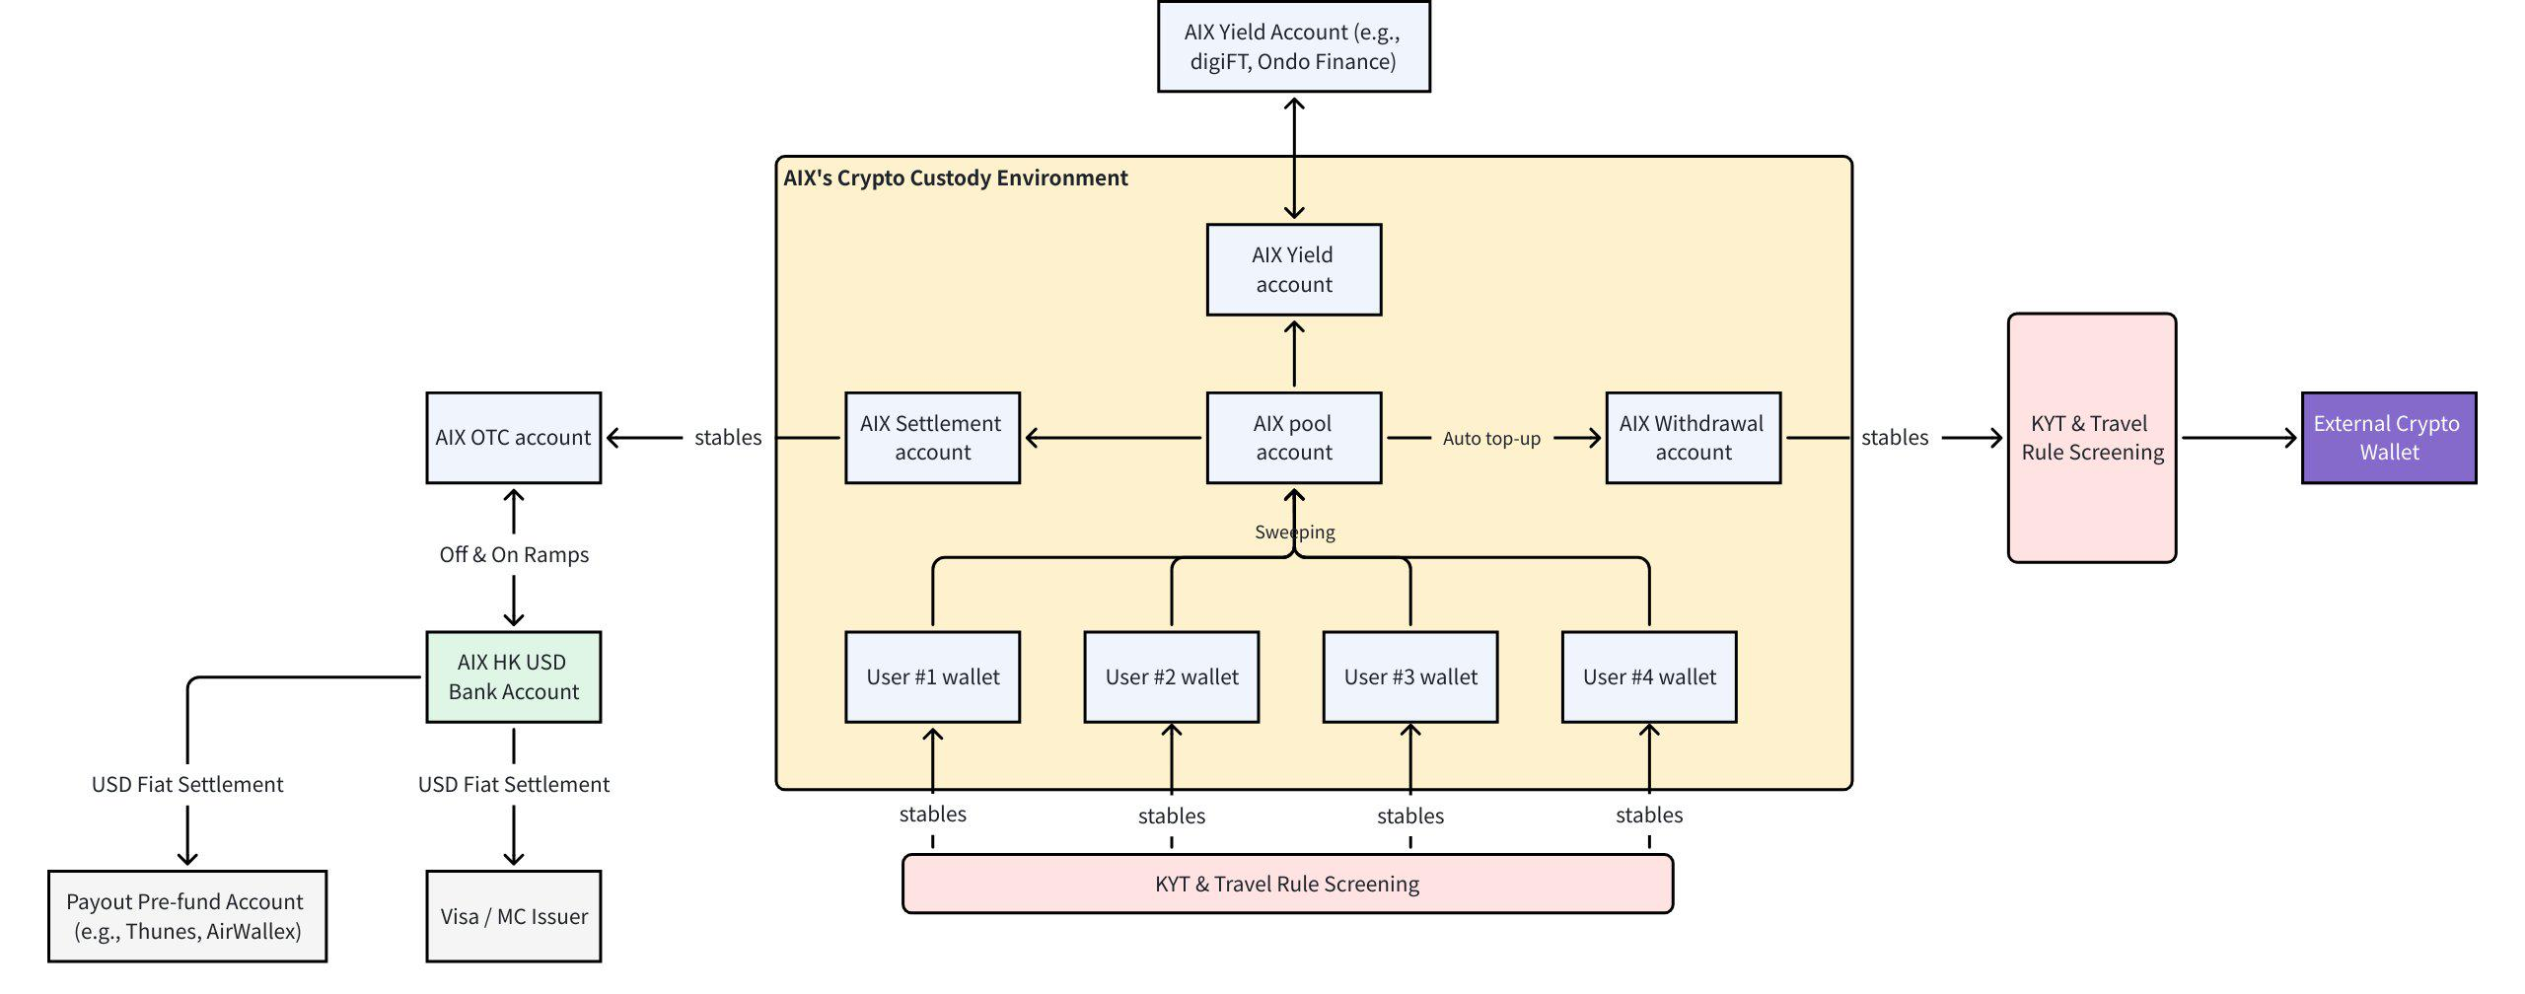

4.1 Account Opening KYC
@Yifeng Wu 吴忆锋Can you attach the current account opening KYC flow with dtcPay? It should remain the same, with dtcPay replaced by KUN

4.2 Card Application
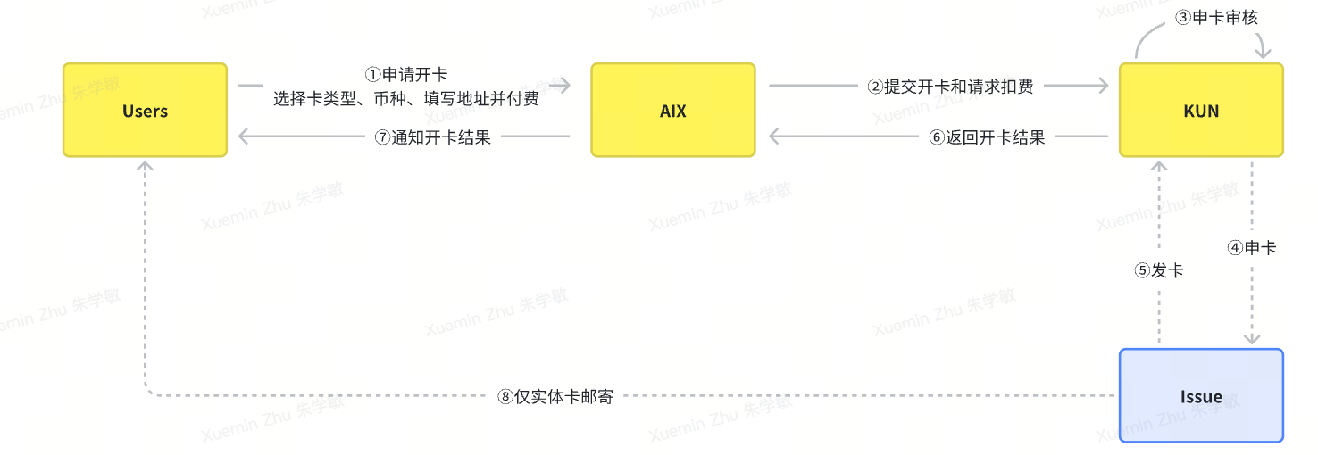

4.3 Card Management Flow
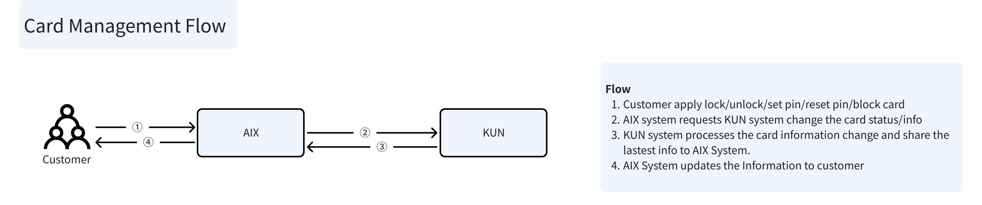

4.4 On-chain Deposit with KYT and Travel Rule
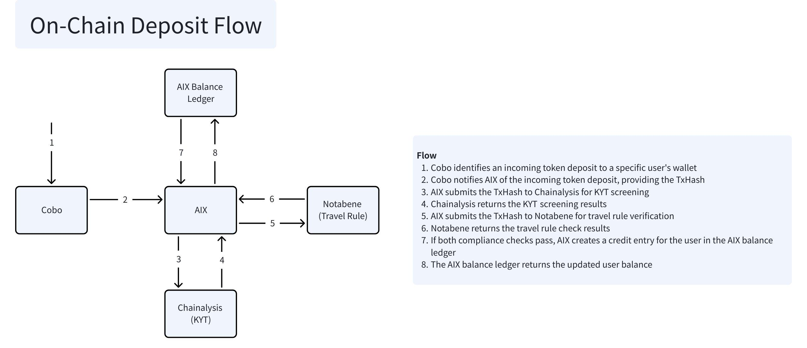

4.5 On-Chain Withdrawal with KYT and Travel Rule
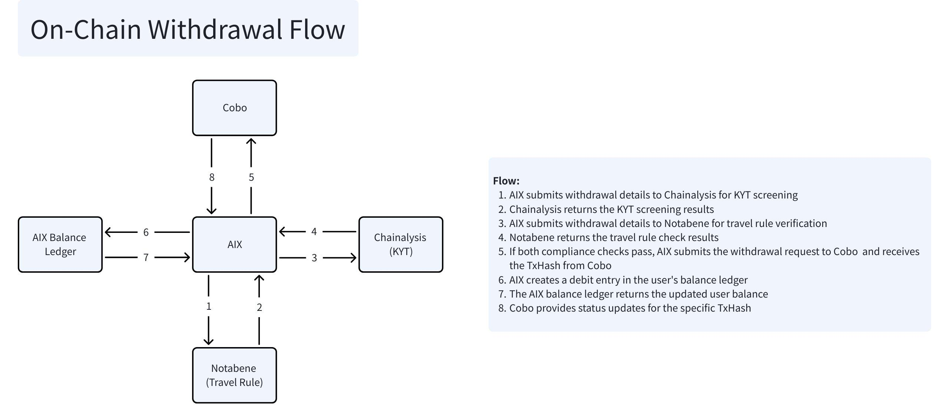

4.6 Token Swapping
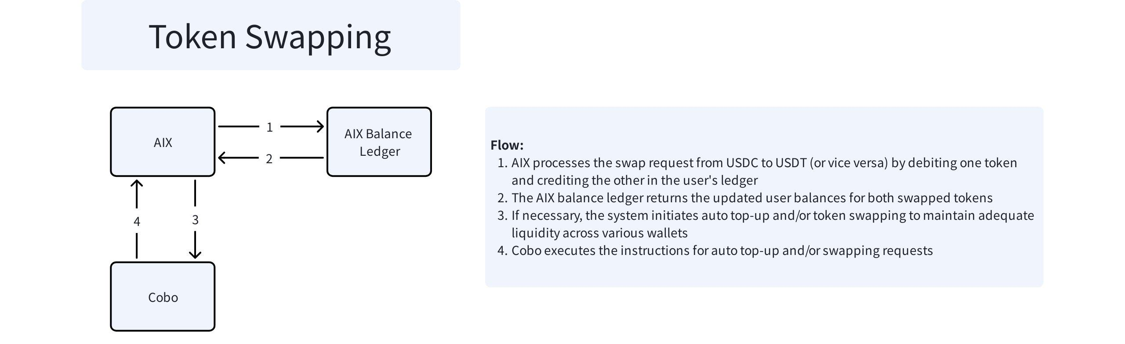

4.7 Yield Account
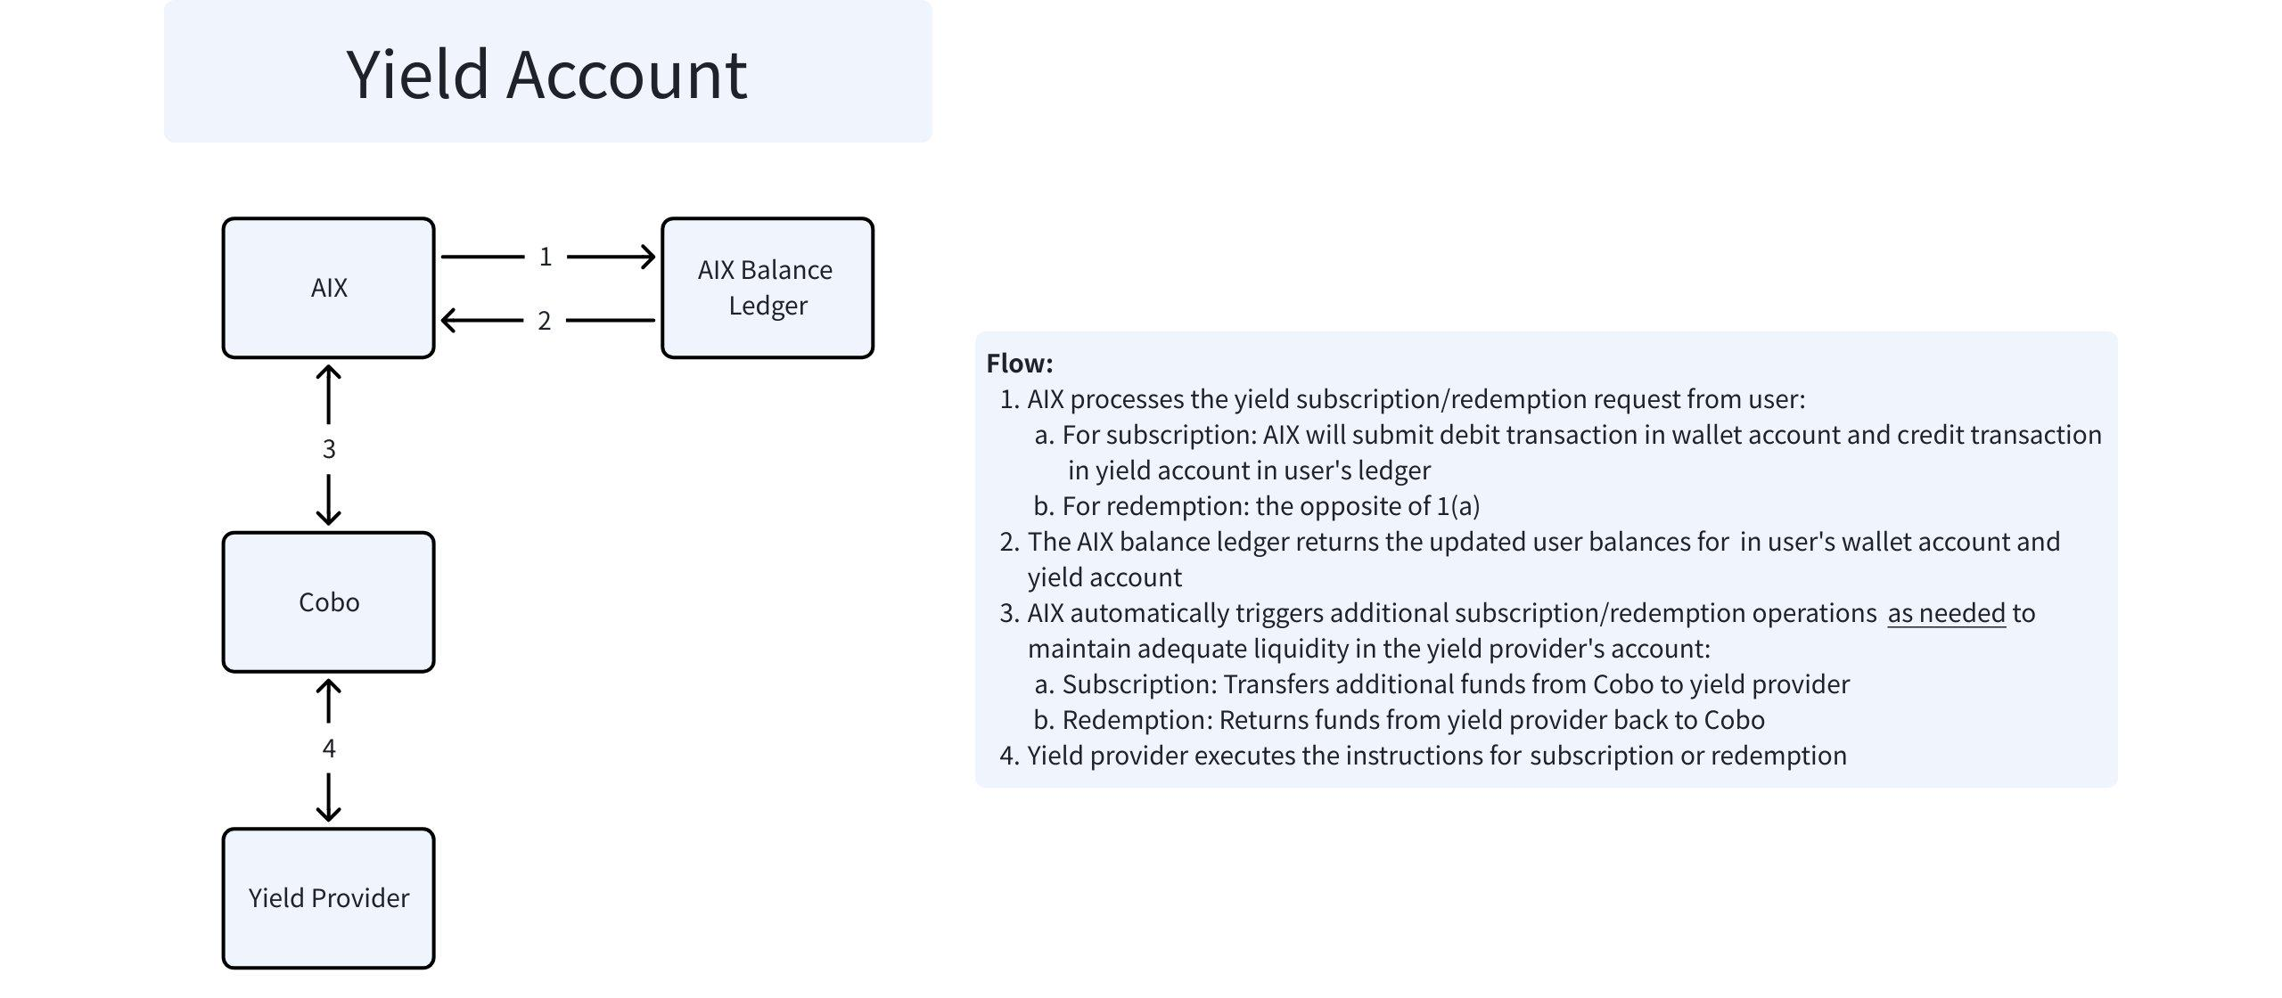

4.8 Card Transactions (Auth & Capture)
Replace Rain with KUN
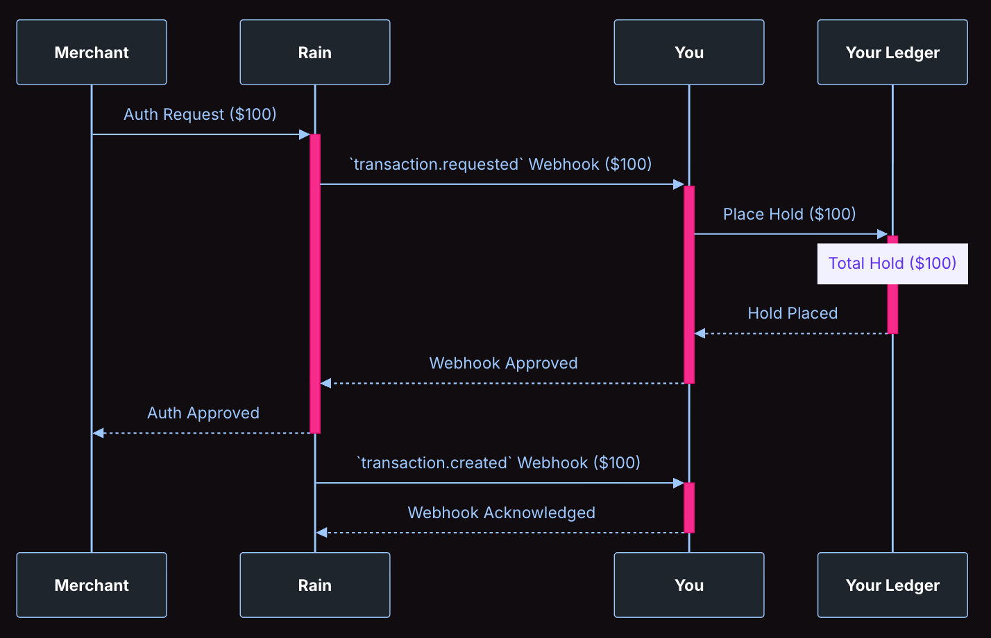
Auth Flow
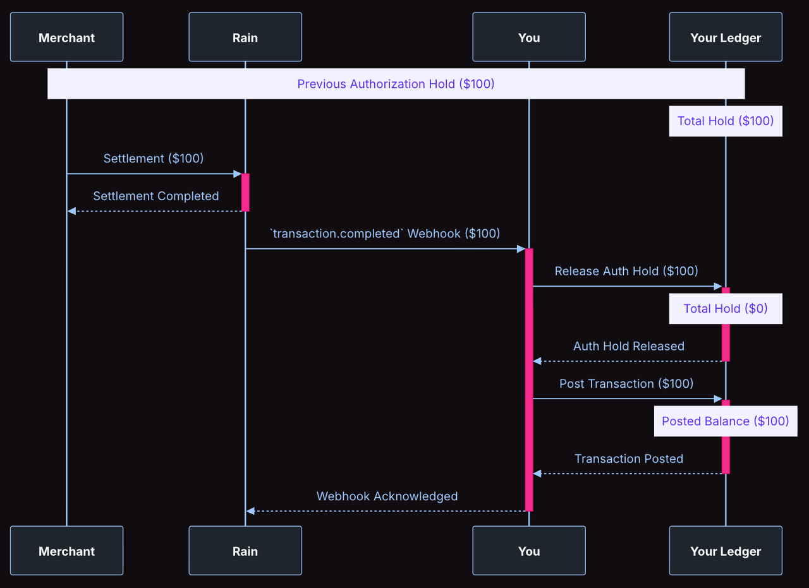
Capture Flow

4.9 Refund
Replace Rain with KUN
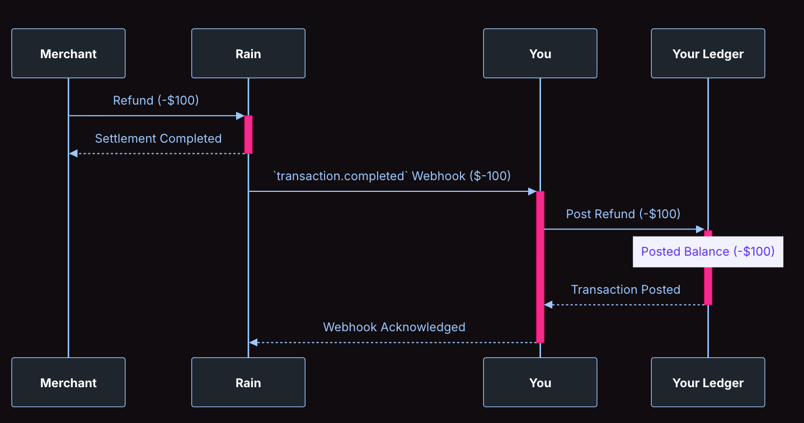
Refund Flow

5. External dependencies and constraints
- Dependent external roles/systems:
- ☐ Custody Provider
- ☐ Issuer / BIN
- ☐ KYT
- Travel Rule Vendor
- Banks/Payment Institutions
- Other

6. Uncertainty and risk
- Currently identified uncertain points or risks:
- Factors that may affect the rhythm or scope of Phase 2:

